**Experiment Name:** Implementation of Banker's Algorithm.

**Experiment No:** 09

**Objectives:** In this lab we will Learn about Bankers algorithm and Implement Bankers algorithm by using c program. And testing the program different input and find output .

**Bankers algorithm:**

The banker’s algorithm is a resource allocation and deadlock avoidance algorithm that tests for safety by simulating the allocation for predetermined maximum possible amounts of all resources, then makes an “s-state” check to test for possible activities, before deciding whether allocation should be allowed to continue..

**CODE:**

#include<stdio.h>

int main()

{

int Allocation[100][100],max[100][100],

Available[100],NeedMatrix[100][100],i,j,k=0,

order[100],n,m,count=0;

int finish[100]={0};

printf("Enter Number of process:");

scanf("%d",&n);

printf("\nEnter Number of Resources:");

scanf("%d",&m);

printf("\nEnter Allocation Matrix:\n");

for(i=0;i<n;i++)

for(j=0;j<m;j++)

scanf("%d",&Allocation[i][j]);

printf("\nEnter Max Allocation Matrix:\n");

for(i=0;i<n;i++)

for(j=0;j<m;j++)

scanf("%d",&max[i][j]);

printf("\nEnter Available:\n");

for(j=0;j<m;j++)

scanf("%d",&Available[j]);

printf("\n\nNeed Matrix is:\n");

for(i=0;i<n;i++)

{

for(j=0;j<m;j++){

NeedMatrix[i][j]=max[i][j]-Allocation[i][j];

printf("%d ",NeedMatrix[i][j]);

}

printf("\n");

}

begin:

for(i=0;i<n;i++){

count=0;

if(finish[i]==0){

for(j=0;j<m;j++){

if(Available[j]>=NeedMatrix[i][j])

count++;

else

break;

}

if(count==m){

finish[i]=1;

for(j=0;j<m;j++){

Available[j]=Available[j]+Allocation[i][j];

}

order[k++]=i;

}

}

}

for(i=0;i<n;i++)

{if(finish[i]==0)

goto begin;

}

printf("\n\nSequence is:\n\n");

for(i=0;i<n;i++){

printf("p%d",order[i]);

if(i<n-1)

printf("->");

}

printf("\n\n");

return 0;

}

**Output:**

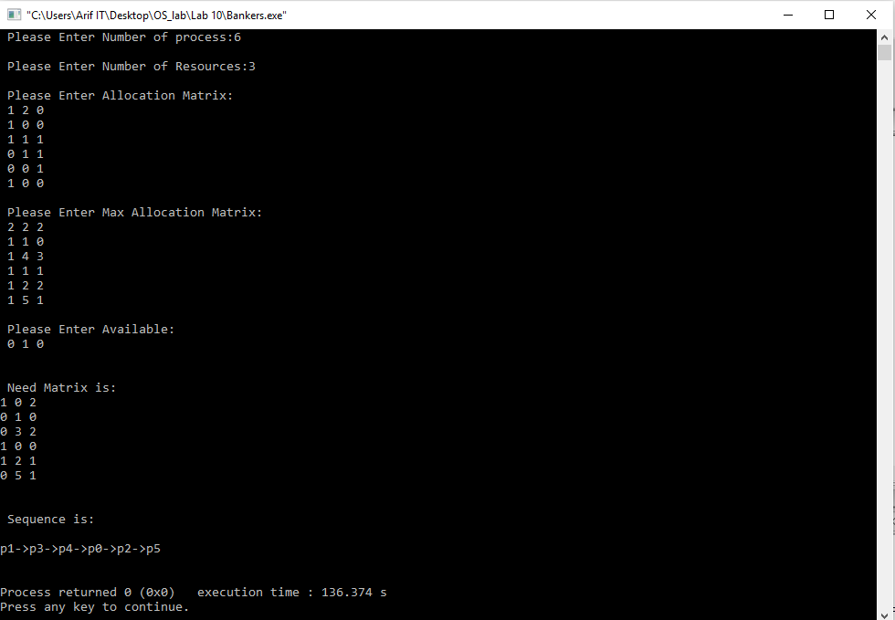

**Conclusion :**

After doing this lab report we learn about Bankers algorithm and also learn how to implement Bankers algorithm by using C program and testing the program different input and find output .

Finally we learned about bankers algoritm without any error .